* 1. Current Technology

Autonomous vehicles can be classified into different levels of autonomy based on the scope of responsibility dedicated to the vehicle computer. According to *SAE Recommended Practice J306 2018.* These levels of autonomy are based on the responsibility of Dynamic Driving Tasks (or DDT). DDTs can be classified into two main tasks: Longitudinal DDTs and Lateral DDTs. Longitudinal DDTs focuses on controlling the brake and throttle to maintain speeds and prevent crashes. Lateral DDTs involve maintaining vehicle travel direction by modulating differential wheel braking to electric power-steering. DDTs can be performed by either a human driver or an autonomous controller in the vehicle. The more DDT tasks that the vehicle controller is responsible for, the higher the autonomy level. In general, from levels 0 through 2, a human driver performs all DDTs. From levels 3 through 5, a controller takes over a greater percentage of DDTs such that at level 5 autonomy the vehicle is 100% independent of the driver. Currently, no level 5 autonomy vehicle exists on the current market [5].

The level of autonomy depends heavily on the type of sensors a vehicle has onboard. These sensors were discussed previously [6]. A simple overview of the main sensors in a vehicle is shown in Figure 3. These sensors can be used for two main functions: localization and environment recognition. Environment recognition can be in the form of light sensors, or ultrasound sensors. Localization sensors are usually Global Positioning Systems in conjunction with other sensors to create position estimates. Environment recognition sensors depend on many factors such as the amount of brightness, the quality of paint in lane markings, and background information that can make feature identification more difficult. For positioning, GPS has presented a degree of error around 6 feet which is enough to misplace a vehicle in a different lane [7].

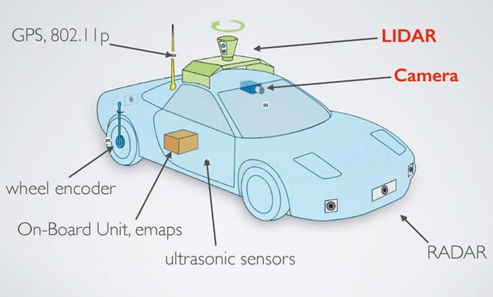

Add a little explanation on how Control Systems work with the aid of Sensors.

In recent years, infrastructure has been used as a new medium for providing more information to autonomous vehicles. For example, V2I communication have been expanding as a new area of research in the transportation field. This type of communication has been used to provide traffic flow data to vehicles that come from a station monitoring current state of traffic during any given day. As of today, V2I schemes are still in development and being tested by Department of Transportation (DOT) facilities.

Add more V2I Technology explanation.

A more detailed review of the technology available in autonomous

To achieve a step closer on level 5 autonomy, the next section proposes a system that is not solely dependent of the information gather by sensors, but utilizes external road data information to guide the vehicle. The systems utilizes V2I communications along with road geometry data to provide the necessary information to the vehicle so that it may reliably stay on the road. Instead of replacing current technology, the system is meant to strengthen current systems as an additional level a redundancy.